 | A group or chain of islands clustered together in a sea or ocean.
How was it formed? | Examples

 | A deep valley with very steep sides.
How was it formed? | Examples

 | A long crack in the surface of the Earth.
How was it formed? | Examples
 | A ring (or partial ring) of coral that forms an island in an ocean or sea. The coral sits atop a submerged volcanic cone.
How was it formed? | Examples

 | A low, watery land formed at the mouth of a river; often (but not always) shaped like a triangle.
How was it formed? | Examples

 | An area of land that receives no more than 25 centimeters (10 inches) of precipitation a year.
How was it formed? | Examples

 | A long, narrow sea inlet that is bordered by steep slopes.
How was it formed? | Examples

 | A long-lasting, slow-moving mass of ice on land.
How was it formed? | Examples

 | A part of the ocean (or sea) that is party surrounded by land (usually larger than a bay)
How was it formed? | Examples
 | A raised area or mound of land.
How was it formed? | Examples

 | A piece of land that is completely surrounded by water.
How was it formed? | Examples

 | A narrow strip of land connecting two larger landmasses; has water on two sides.
How was it formed? | Examples
 | A large body of water surrounded by land on all sides.
How was it formed? | Examples

 | A body of land that is surrounded by water on three sides.
How was it formed? | Examples

 | A large, flat area of land that is higher than the surrounding land.
How was it formed? | Examples
 | A very tall, high, natural place on Earth – higher than a hill.
How was it formed? | Examples

 | Flat lands that have only small changes in elevation.
How was it formed? | Examples

 | A ridge of jagged rock, coral, or sand just above or below the surface of the sea.
How was it formed? | Examples
 | A large, flowing, body of water that usually empties into a sea or ocean.
How was it formed? | Examples

 | A narrow body of water that connects two larger bodies of water.
How was it formed? | Examples

 | An opening in the Earth's crust, through which lava, ash, and gases erupt into the atmosphere.
How was it formed? | Examples
 | A large body of salty water that is often connected to an ocean; may be partly or completely surrounded by land
How was it formed? | Examples

 | A low place between mountains.
How was it formed? | Examples

 | A long, narrow island of sand and/or gravel that are usually aligned parallel to the shore of some coasts.
How was it formed? | Examples
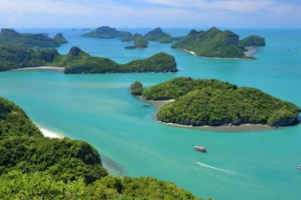
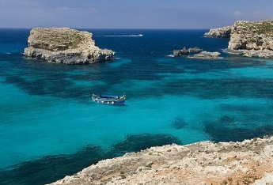
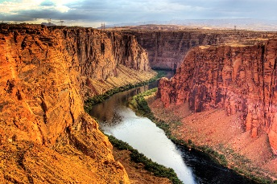
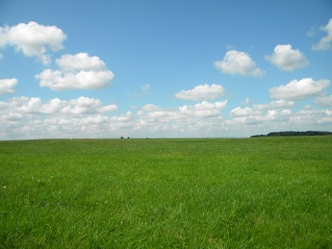

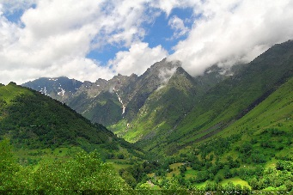
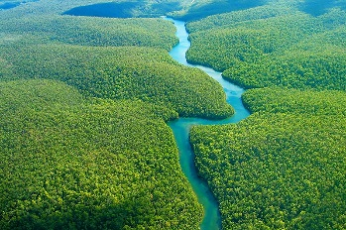
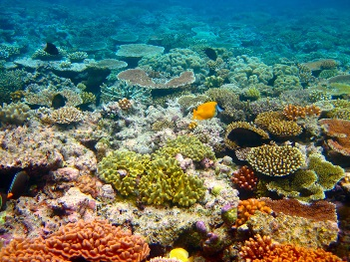
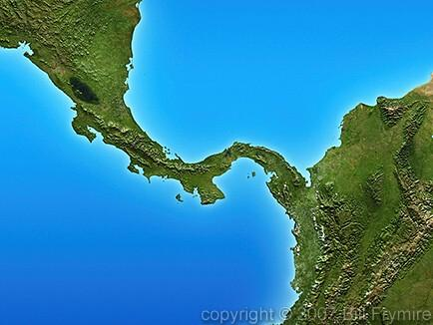
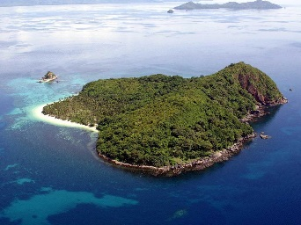
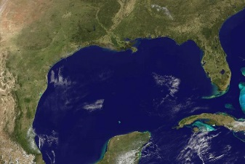
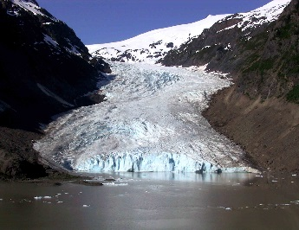
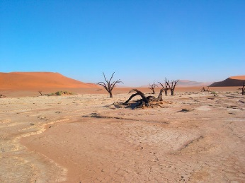
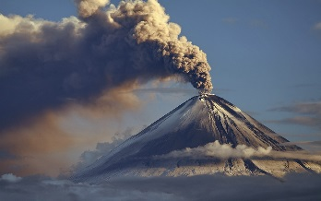
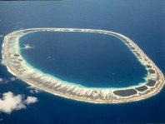
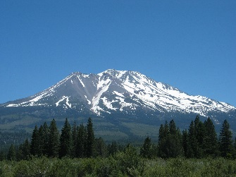
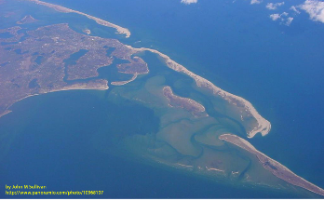
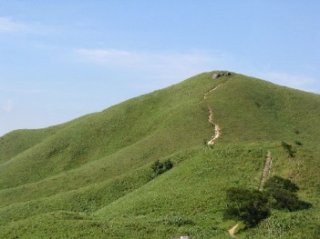
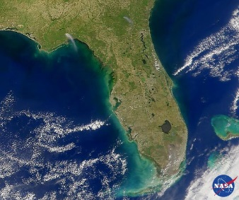
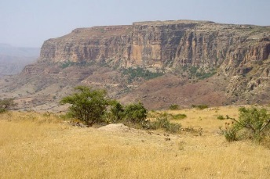
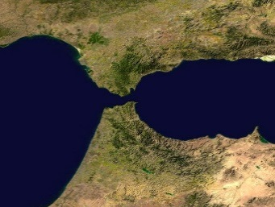
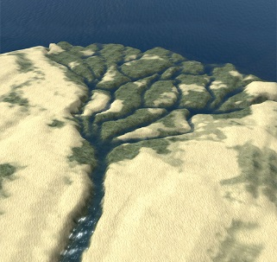
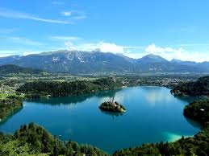
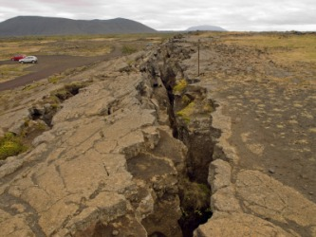
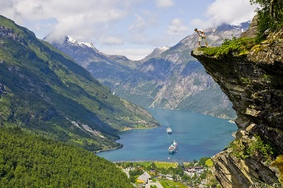
GLACIER
VALLEY
RIVER
REEF
ISTHMUS
ISLAND
GULF
DESERT
VOLCANO
ATOLL
MOUNTAIN
BARRIER ISLAND
HILL
PENINSULA
PLATEAU
STRAIT
DELTA
LAKE
FAULT
FJORD
ARCHIPELAGO
SEA
CANYON
PLAIN

of Gibraltar
Bering
of Magellan

Death
Great Rift
Napa

Maldives
Bikini
Tikehau

Great Barrier
Florida Keys
Belize

Alps
Himalayas
Andes

Persian
of Mexico
of California

Nile
Amazon
Yangtze

Arabian
Korean
Iberian

San Andreas
Denali
Atacama

Great
Serengeti
Pampas

Kenai
Milford Sound
Geirangerfjord

Red
Mediterranean
Black
Philippines
Bahamas
Hawaii

South Padre
Hatteras
Outer Banks

Grand
Colca
Copper

Bunker
Nob
One Tree

Popocatépetl
St. Helens
Vesuvius
Cuba
Madagascar
Iceland

Atacama
Gobi
Sahara

Erie
Great Salt ___
Victoria

Edwards
Tibetan
Andean

of Panama
of Suez
Seattle

Nile River
Mississippi River
Ganges & Brahmaputra

Margerie
Canada
Columbia

